PRACTICAL 3: LS COMMANDS

-Shrisai Halankar

1. List all the files and directories



2. List all the files and directories in multicolumn format

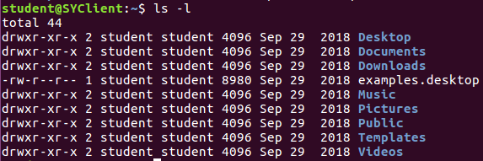

3. List all files identifying directories and executable files



4. List the contents of the directory along with all the hidden files



5. List recursive list of all files and directories

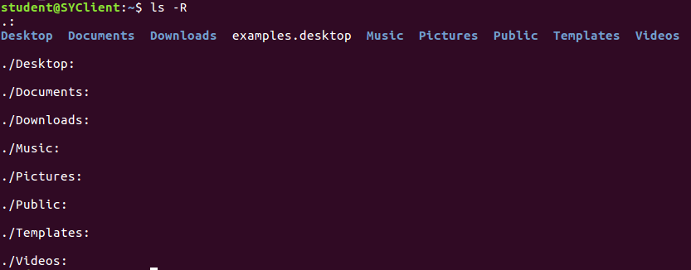

6. Give the file listing in reverse order



7. Give long listing of all files and directories

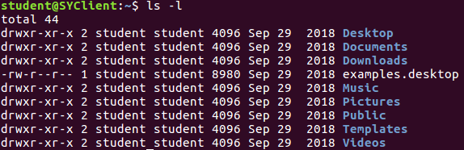

8. List all file names sorted by last modification time



9. Displays all files sorted according to the extension



10. Displays all files sorted according to the extension in the reverse

Order



11. Displays all the files sorted according to the last modification time in

the reverse order



12. Display all files and directories including hidden files and executable

Files



13. Display detailed listing including hidden files sorted in reverse order

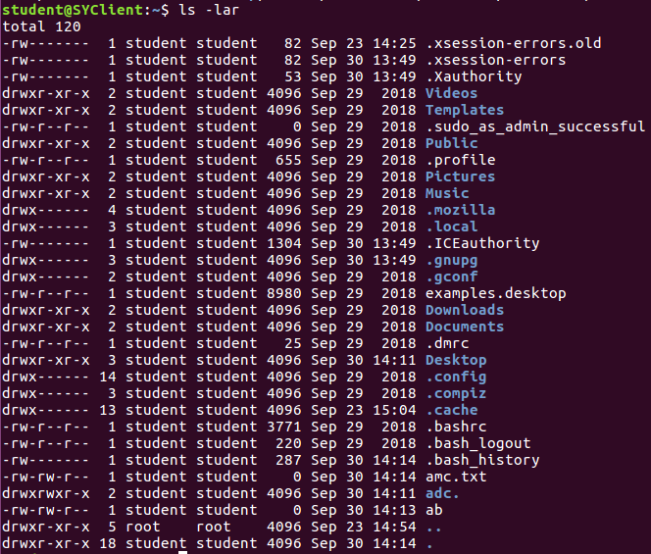

14. List the contents of the directory



15. Give listing of “shri” with their attributes and files permissions.

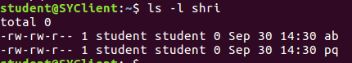

16. List all filenames with one screen at a time

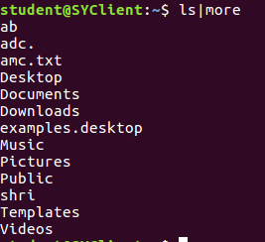

17. List all filenames with two characters



18. List all file names with 3 characters

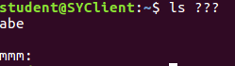

19. List all filenames starting with a lowercase letter ‘a’

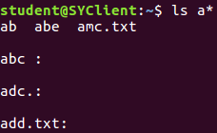

20. List all file names starting with uppercase ‘A’



21.list all file names staring with vowel

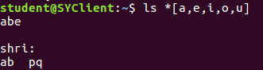

22. List all filenames with the last character as ‘a’or’b’or’c’or’d’

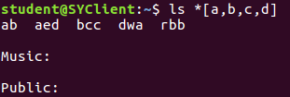

23. List all filenames with exactly three characters in which the second

character is a vowel



24. List all the file names with three characters in which first character is an uppercase and second character is a digit



25. List all filenames starting with an uppercase letter vowel and ends with a digit



26. List all the file names in which the last character is a digit in the ranger 1to 9



27.list all the file names with four characters in which the first character is ‘a’ and third is ‘d’



28. List all filenames whose first character is anything other than a small

case letter vowel

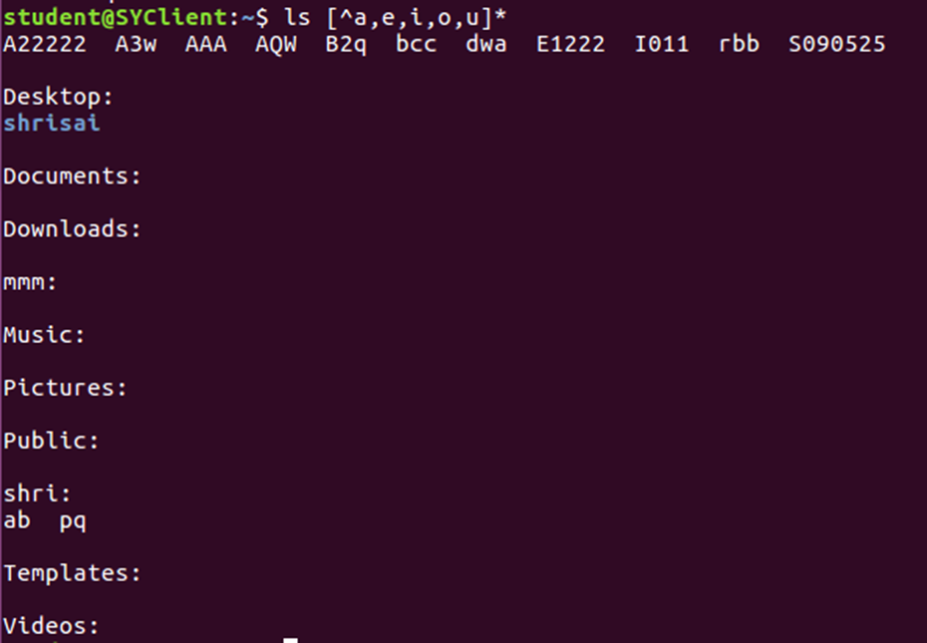

29. List all files and directories with five characters whose first character is in the range a to m,second character is in the range c to z and third is the digit in the range 4 to 9

ls [a-m][c-z][4-9]??



30. Find the type of all the files

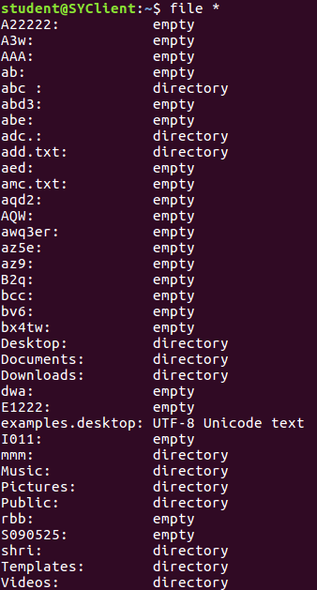

31. Display the count the number of lines, number of words



32. Display and count the number of lines of file “AAA”



33. Display and count the number of words of file AAA



34. Display the count the number of characters of file AAA



35. Display the number of count of lines,words and characters of file “AAA” and “A3w” and “abe”

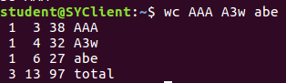

36. Count the number of files and directories



37. Count the number of users currently logged in to the system



38. Store the number of users currently logged in to the system in file “test”



39. Display and store the listing of all filenames in file “list”

